
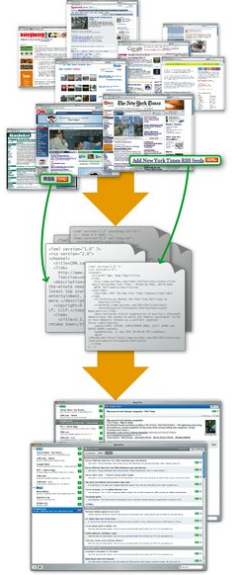

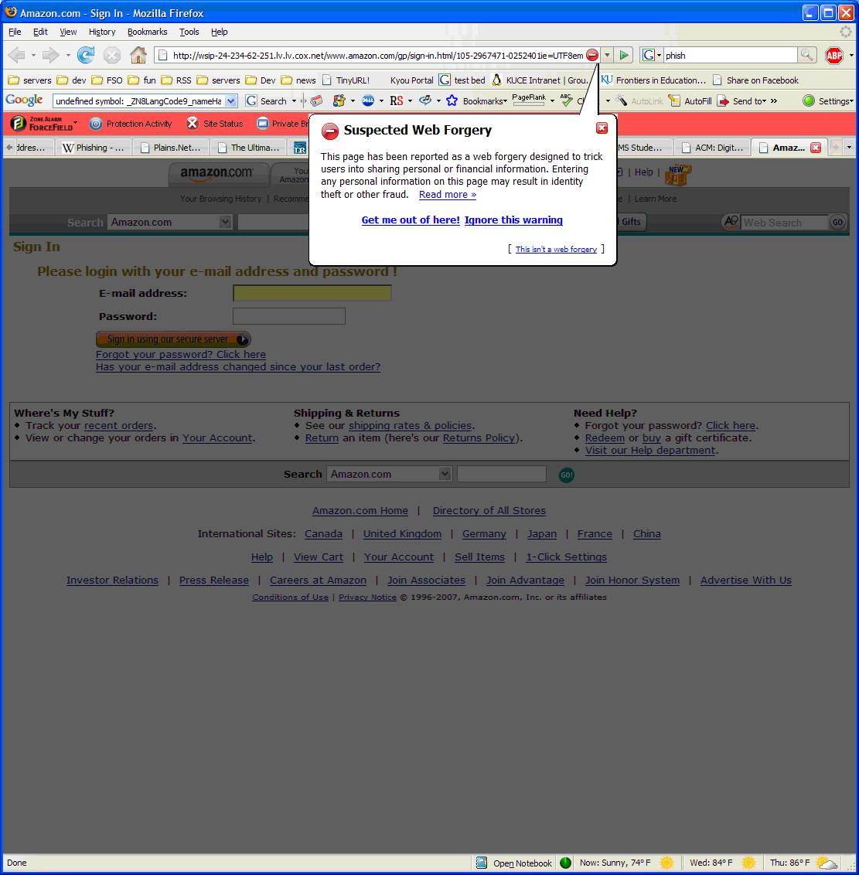
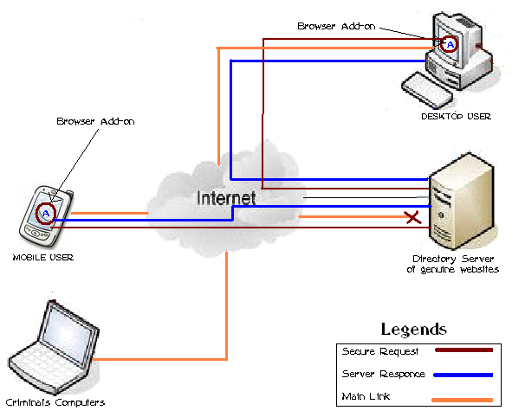
Phishing scams and its countermeasures
Prepared By Imran Khan (52303) Supervised by Khalid Khan

PROBLEM
Phishers are more sophisticated

Existing anti-phishing mechanism does not working efficient against phishing attack; because phishers changing their techniques time to time.

Fake
Website
Genuine
Website
PHISHING ADD-ON
Providing Reliability

A unique browser-add-on is required which gathers directory of world major financial institutions and
Online shop’s, whenever user goes outside of these genuine Websites, add-on generates warning message to user.

IMPLIMENTATION
How it works
Browser-add-on is a client based
utility Based on directory Server,
which gathers genuine
Web directory of all major
financial Institutions such as
banks, online shops etc.

1st of all user have to installed a
special browser add-on, that add-on
updating it’s database with directory
server, and providing reports to user
about updated list, when user trap
by phisher and goes to fake
website, then add-on hold to user and will request to directory server about confirmation of genuine website, if directory server replied positive then add-on will gives to allow, otherwise generate error like “website doesn’t found in safe list, you’re advised to leave this website, or you may use on your own risk”. After that warning user will take decision whether he/she will attempt to that website or quit from that.

OPEN ISSUES
Future Works

Add-on tool should be globalized, whenever any new financial institutions will launch then they have to send request for updating their genuine website into directory server.

INTRODUCTION
What is Phishing?
Phishing is part of cyber crime in which criminal perform a fraudulently activity by making fake website sites similar to genuine in order to trap user to given up their personal financial information which will used for identity theft or other criminal activity. Phishing is most commonly perpetrated through the mass distribution of e-mail messages directing users to a web site, but other venues are
utilized as well.

In e-commerce environment, different people hold information that can be considered sensitive or else can be particularly useful to outside parties. A phishing attacker will make use of non-technical (such as social engineering) methods to gain that information.

